Fundamentals of Object Oriented Programming - Abstract classes -

Abstract Classes

In an inheritance hierarchy, it is not always necessary that all participating grades concrete objects must be created. It may well be parents-classes, who need not be instantiable - because often there are base classes only for the purpose of defining a basic set of attributes and methods, which is passed to the subclass (es). In this case, you define a parent class as an abstract class - then it is not allowed to create objects of that class.

Example car purchase: THE Porsche there is not to buy, but only a specific model, such as the 911, Boxster ...In OOP you would class the Porsche define an abstract class and it is not possible to create objects of that class.Of a derived class (forPorscheBoxster example) could then create objects.

Example Employee: An employee object can not exist, because it lacks important attributes (salary, orWage). The class representative can therefore be declared abstract. Concrete classes would then be about employees or workers.

No objects of an abstract class can be generated - but there may be other classes derived from it, which can then be used for object creation.

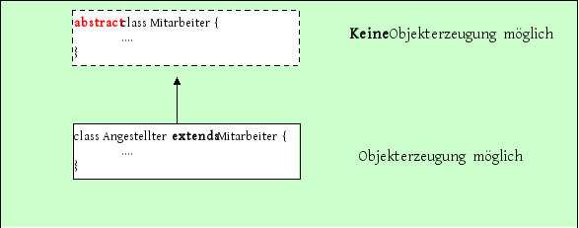

In an abstract class, it can be any number of attributes and methods (including constructors).However, they can only be used by an object of a derived class.

/ / / / / / / / / / / / / / / / / / / / / / / / / / / / / / / / / / / / / / / / / / / / / / / / / / / / / / / / / / / / / / / / / / /
/ / BASE CLASS

abstract class Employee {

static int objektZaehler;

int EmployeeID;
String name;
String versNr;

public Employee (String name1, String versNr1) {

name = name1;
versNr = versNr1;
EmployeeID = + + objektZaehler;
System.out.println ("--------------------- \ n" +
"Base class constructor \ n");
}
}

/ / / / / / / / / / / / / / / / / / / / / / / / / / / / / / / / / / / / / / / / / / / / / / / / / / / / / / / / / / / / / / / /
/ / DERIVED CLASS

class Employee extends employee {

double salary;

public Employee (String name1,
String versNr1,
double gehalt1) {

super (name1, versNr1) / / call base class constructor

salary = gehalt1; / / Set the attribute of its own

System.out.println ("subclass constructor:");
}
}

/ / Executive class with main / / / / / / / / / / / / / / / / / / / / / / / / / / / / / /

base class Test {

public static void main (String [] a) {

One employee = new Employee ("Mueller"
"3-456-3 km", 2000);
Two employee = new Employee ("Fritz", "1111111", 500);

}
}

The compiler error employee is abstract, can not be instantiated
indicates that no objects can be created from an abstract class.

Reference variable of an abstract class

From an abstract class that you have no objects can be created in a direct way - but it is quite possible to create a reference variable of the type of abstract class.



If a specific object is to be created, the constructor must have a concrete derived class.



Another great advantage of abstract classes is the ability to form arrays that can accommodate all subclass objects.In association with abstract methods, the possibilities of virtual methods that are called at runtime for the correct Subklassentypus open up so (see the following chapter - Polymorphism).


Page 3

