Fundamentals of Object Oriented Programming - Control structures

Control structures / flow control

Only for very simple exercise programs Programmmablauf is linear and sequential. A real program control structures used to control the precise end result of user input or status inquiries.As in C and C + + can be two basic types of flow control are different:

- Each branch in different sections of the program (Alternative)
- Repetition of a particular sub-section (loop)

In both groups there are several sub-types that are defined by different key words.

If the program flow encounters such a control instruction, the conditional expression is executed.This program states can (usually the contents of variables) queried. The associated actions are defined in a separate statement block {}.

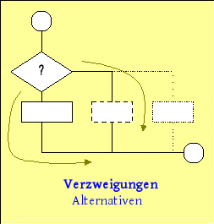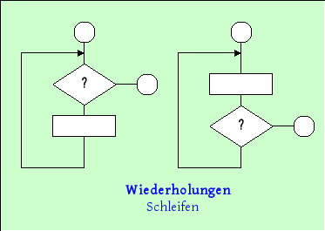

The chosen representation in the following chapter is based on the standardized organizational model of program execution plan (PAP), which is particularly suitable for the visual representation of complete programs while structure diagrams are used for more detailed representation of individual control structures.

Flowcharts are generally well suited to model complex flow structures. They are often used in procedural languages ​​such as C. Object-oriented programming are also required for the use of class models that do not model the actual program run, but primarily the ratio of classes or Represent objects to each other. For this purpose, the UML is a suitable modeling tool.
Page 1

